Crypt-Arithmetic Problem
AIM:
To write a Python program to solve a Crypt-Arithmetic Problem by assigning unique digits to letters to satisfy a mathematical equation.

Algorithm:

- Start the program.
- Read the given arithmetic expression containing letters.
- Identify all unique letters in the expression.
- Assign different digits to the letters.
- Ensure that leading letters of multi-digit numbers are not assigned zero.
- Substitute the digits into the expression.
- Check whether the arithmetic equation is valid.
- Display the valid digit assignment if a solution exists.
- Stop the program.

Code :
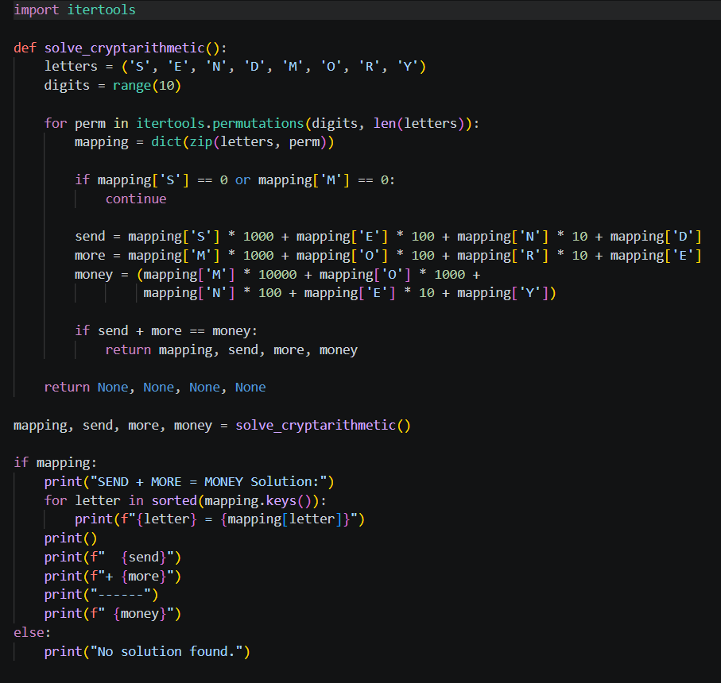
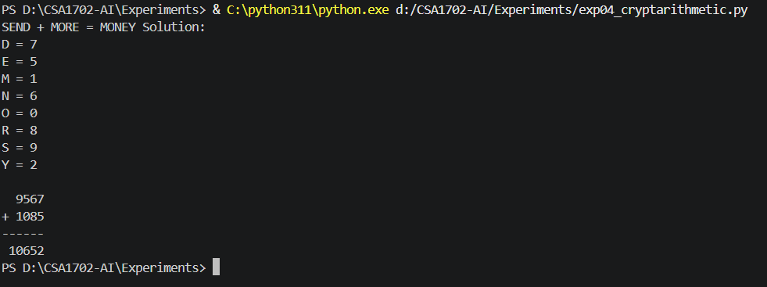
Output :
Result :
Thus, the Python program to solve the Crypt-Arithmetic Problem was executed successfully.

